Phase 2 Source Code

Rohandra Malcolm

Dobrian Zaprianov

Diamon Zetty

Dorrell Zimmerman

25 June 2024

Phase 2 Evaluation:

Reflecting on things that could be change to better enhance application for Phase 2 there were a number of additional changes that were made to application. There were cosmetic changes that were made to the templates, such as disclaimers and additional infographics to better inform user of the data results. Python code was changed in order to provide decrease the size of the number that user was given by adjusting it to 3 decimal points for BMI and 2 decimal points for BMR. Code was altered and cleaned with added comments to provide a more stable version of the application. Unit Test were ran again to ensure that any changes made to code did not break any functionality of application.

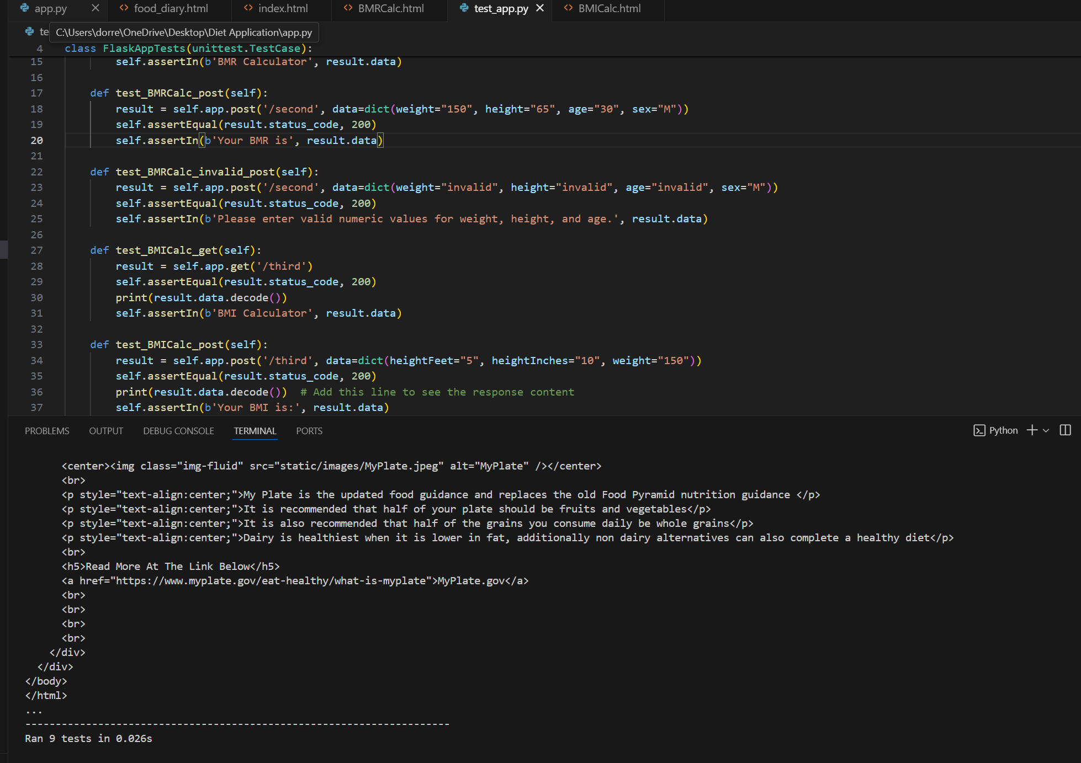

Figure 1: Unit Test of updated Flask Code

Figure 2: Updated Flask Code

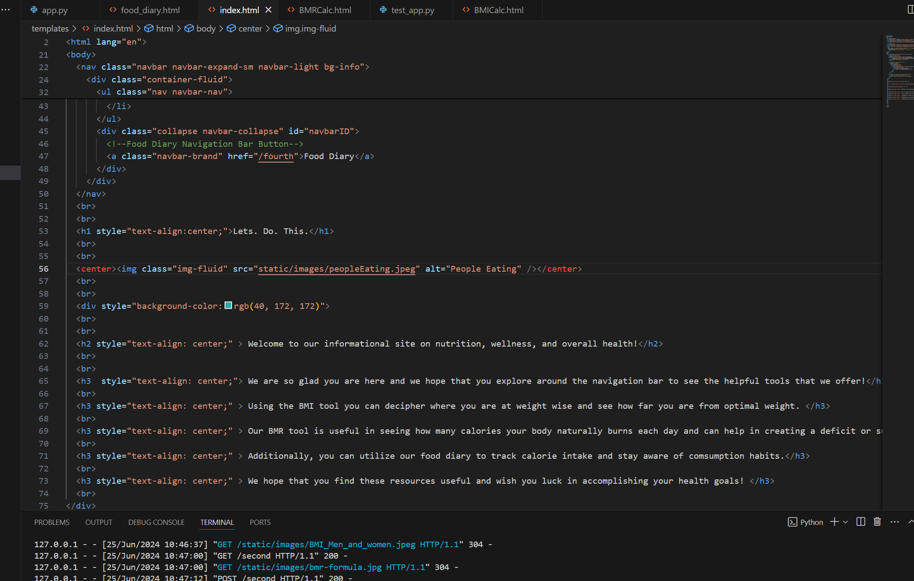

Figure 3: Updated index.html source code

Figure 4: Updated index.html page for Diet Application

Figure 5: Updated BMICalc.html source code

Figure 6: BMICalc.html page with successful BMI calculation updated to only show 3 decimal points with disclaimer and infographic.

Figure 7: Updated BMRCalc.html Source Code

Figure 8: BMRCalc.html page with successful BMR calculation updated to show only 2 decimal points with disclaimer and infographic.

Figure 9: Updated food_diary.html source code

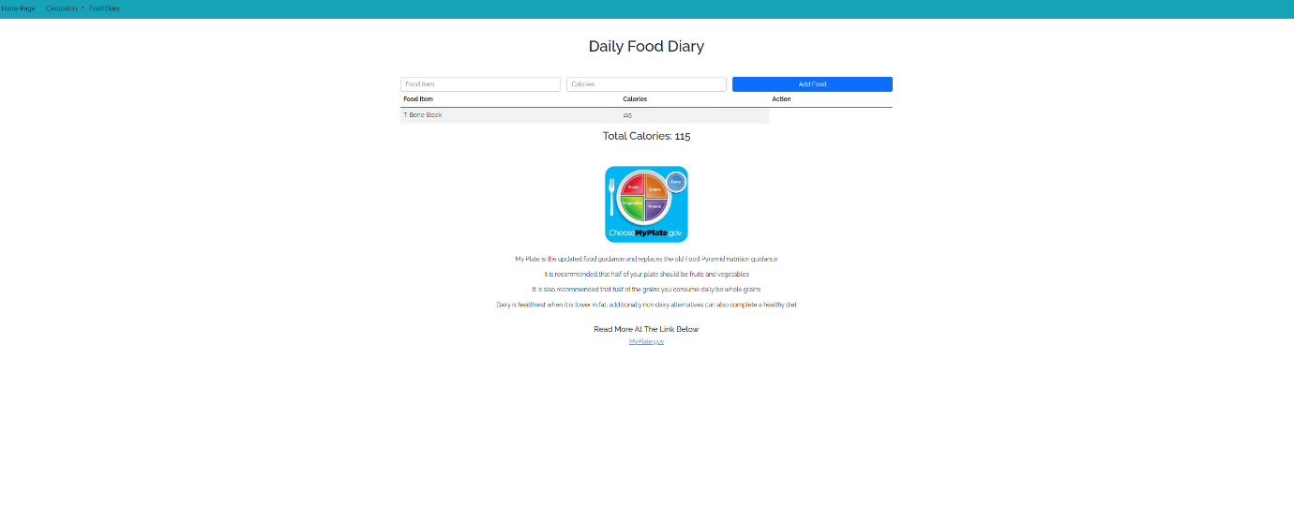

Figure 10: Update Food Diary page with infographic

Conclusion: This program not functions effectively providing the wanted functionalities. The addition of infographics assists in providing the user with the information needed to interpret the data and provide a better understanding of application data.